Rocky Mountain RPG Guild
A Guide on your journey to share the fun and adventure of games with friends, old and new.
  - Judges Guide 2019

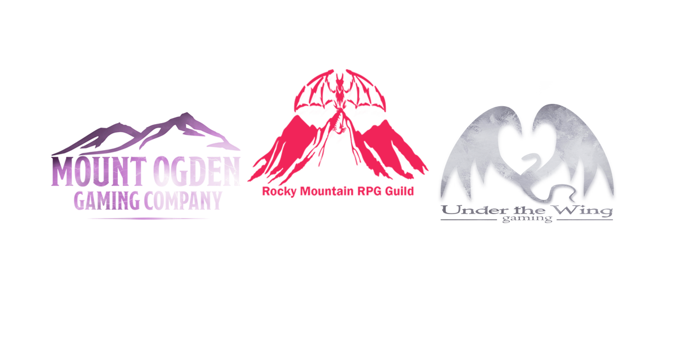
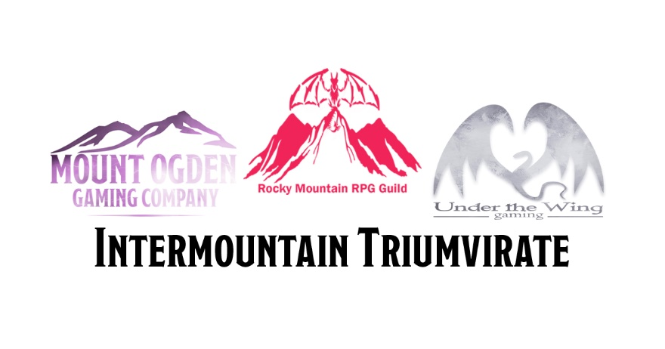
Table of Contents
Introduction 2
Summary 2
Expectations 2
Requirements 3
Support 4
Communication Tools 4
Appeals 4
Troublesome Players 4
Judge Rewards 4
Disciplinary Options 4
Appendix A: Tabletop RPGs 5
Summary 5
Requirements 5
Appendix B: D&D Adventurers League Code of Conduct 6
Appendix B: SaltCON GM Code of Conduct 8
Behavior 8
Communication 8
Presentation 8
For DDAL 8
For SaltCON 8

Rocky Mountain RPG Guild Judges Guide

Introduction
Welcome to the team! Thank you for volunteering to run events for Rocky Mountain RPG Guild. We have provided this guide to assist you in making your volunteer experience as pleasant as possible.

Volunteering at a show can feel like a thankless job, but rest assured that the players you are entertaining, and the Organizers are very thankful to you. The players will remember the fun they had with you, and if you show them a good time, they will ask for you year after year. That feels pretty darn good.

Reminder registering and/or accepting the badge for a convention as a volunteer, does not constitute an agreement of employment by either Rocky Mountain RPG Guild or the convention. You also understand that while you may receive gifts or badges for your volunteering time, they are not compensation for any time spent volunteering, and do not entitle you to benefits, including employment insurance benefits upon the termination of this agreement or as a result of this service.

This guide will help you understand what is expected of you, your duties, and what kind of support you can expect from your Organizers.

Your first task is to read this document in full and ask for clarification on anything that you are not clear on.

Rocky Mountain RPG Guild organizes, schedules, promotes, and staffs gaming events at conventions in the Rocky Mountain region of the US. Currently RMRPGG consistently runs events at:
SaltCON Spring February 28th-March 3rd
SaltCON Summer May 31st-June 1st
Ogden UnCon June 7th-9th
Salt Lake Gaming Con June 27th -29th
MyCon August 16th-17th
SaltCon End of Summer August 30th-31st
Anime Banzai October 18th-20th
TIMPCON October 18th-20th
​

The three logos on the cover are for Mount Ogden Gaming Company, LLC, Under the Wing Gaming, and Rocky Mountain RPG Guild.

Summary
Gaming team members are present to help entertain guests in between panels and other events that the guests would like to attend. Some guests may also come specifically for gaming. Gaming team members should keep their events fun and engaging and should seek out players to fill their event to the minimum needed to run.

Expectations
Below you will find a list of Duties and Responsibilities that apply to our volunteers. Some seem very basic, but we felt them to be important to highlight regardless. While you are running games for RMRPGG, remember that you are providing a service for your customers. Do your best to make sure they leave your table with a smile.

Requirements
- Check-in
  - You must check-in with HQ in gaming once you have arrived (after going through registration)
  - You must check-in if you are going to be late or absent
  - You must check-in at least 10 minutes before your scheduled event
- What to bring
  - A printed copy of your adventure (We will have extras in case)
  - Reference books (Such as Player’s Guides, Monster Manuals, etc.)
  - Maps, minis, writing utensils, note cards
  - Dice
- Hygiene
  - Must be wearing clean clothes that are in good condition
  - Must be bathed and have brushed teeth daily
  - Must wear deodorant (Non-scented is OK)
  - Must NOT wear strong cologne or perfumes
- Behavior
  - When running games, you represent Rocky Mountain RPG Guild and the Convention and act as an ambassador of the companies whose games you are running
  - Behave in a professional manner (avoid foul language and be polite)
  - Do not take out frustrations on players, if you feel yourself loosing control of a situation excuse yourself to HQ.
  - If you need help with a disruptive player, contact HQ
  - Be polite and respectful
  - Follow campaign guidelines (For example Adventurers League or Pathfinder Society Code of Conduct)
- Time Keeping
  - Event slots are in half hour increments
  - Check-in at least 10 minutes prior to your event
  - Volunteers who are constantly late will not be invited back for future shows
  - Watch the clock to make sure you end your event on time
    - End 15 minutes before the end of your time for any paperwork and to clean up your table
    - Use DM tricks to speed up an adventure if it is running late
- Being Released
  - If your schedule event is cancelled, check in with HQ for additional tasks
  - You may be asked to play in a game so that it can fire
  - If released, be back 10 minutes prior to your next scheduled slot
- Food/Drink
  - Make sure to drink plenty water and to eat
  - Keep a small snack and bottle of water in your bag
- Meetings
  - Before each convention there will be a volunteer meeting
  - All volunteers are expected to attend
  - If you cannot attend, contact one of the Organizers
- Have Fun
  - Relax and enjoy yourself

Support
While there are many expectations of you, there is also help available. Before, during, and after the convention the Organizers are here to support you. Be sure to ask any questions you may have.

Communication Tools
RMRPG primarily uses Slack for communication. You will be asked to sign up for and use Slack to receive your adventures or other event materials and to communicate before, during, and after the convention.

You can also contact the Organizers at the following;
- Derek Gray: derek.gray@rockymountainrpg.com
- Dave Knighton: dave@underthewinggaming.com
- David Morris: designer@mountogdengc.com
- Flo Velasquez: dndalflo@gmail.com

Appeals
As the judge for the event you are running, you are empowered to make rulings when there is a rules dispute. Just keep in mind what will be the most fun at the table. In the case that a player will not accept a DMs ruling and a compromise cannot be found, contact HQ.

HQ workers are the senior DMs of the show and their ruling stands. They may be wrong about how a rule works, but the important thing is getting the table back up and running.

Troublesome Players
Rarely, there are disruptive or unruly players. If you feel a player is disrupting your game and you are not able to diffuse the situation, contact HQ. HQ workers can help calm the situation or eject a truly unruly player. You don’t need to be the bad guy.

Judge Rewards
Though we know you are volunteering because your love of gaming, we try to award our volunteers when we can. The rewards for each show vary, but can include some of the following:
- Free passes to the event (minimum volunteer hours required)
- Swag, when made available by the show

Disciplinary Options
Everyone makes mistakes, so most things only require a reminder of how to correct the mistake. However; Rocky Mountain RPG has spent a lot of time and effort on building a great reputation at the shows we run. Because we want to make sure we are putting on fun events and get invited back to the shows, we keep track of our volunteers and their behavior. Discipline can include any of the following;
- Coaching: Being pulled aside and discussing the issue
- Reduced participation: Being scheduled for less events at the next show
- Suspension: Being passed up for the next volunteered show
- Ban: Being marked on our lists as ineligible for volunteering
  - In severe enough cases, an individual will have their show badge revoked and be removed from the premises

Appendix A: Tabletop RPGs

Summary
Role-playing games like Dungeons, and Dragons, Star Trek Adventures, Star Wars: Age of Rebellion, etc.

Requirements

In addition to the requirements laid out earlier in the guide, these are call outs for volunteers working with Role Playing Games

- Read the adventure at least one time prior to your scheduled running time.
  - Some adventures can be badly written, or include complicated scenarios, feel free to ask in Slack for help, or message one of the coordinators for resources.
  - You decide if you want to run with miniatures, tokens and maps, or theater of the mind, but be aware of your players, do not restrict their creativity, if they wish to draw maps etc, empower them.
- Bring the items that you need to comfortably run the game but be advised, there may not be power at the location.
  - Dice
  - Wet erase markers
- Help the guests find a seat
  - Be mindful of how many players have signed up and help them avoid “gamer spread” or taking up more space then is polite.

Appendix B: D&D Adventurers League Code of Conduct
D&D Adventurers League Code of Conduct

All D&D Adventurers League participants are here to have fun and should feel safe and included at all times. All participants (players, Dungeon Masters, and organizers) are expected to adhere to this Code of Conduct.

- Participants must conduct themselves in a manner that is conducive to the enjoyment and safety of others at the event.
- Avoid excessively vulgar, sexual, or overly mature language and themes.
- Follow the DMs lead, avoid arguing with the DM or other players over rules.
- Let other players speak, avoid talking over others.
- Avoid excessive cross-talk that is not relevant to the adventure being played
- Allow other players to get attention from the DM.
- Discourage others from using social media to bully, shame, or intimidate other participants.
- Avoid phone conversations at the table. If you must take a call, please excuse yourself from the table until your call is completed.
- No tolerance is given for theft or aggressive behavior.
- Theft and aggressive behavior are grounds for immediate removal from the play area and the premises.

Aggressive behavior includes threats of or actual physical aggression, using racial, gender, or cultural slurs against another participant, and otherwise harassing other participants.

What To Do?
- Participants who feel as though they are in an unsafe environment should notify the organizer of the event immediately.
- Participants noticing disruptive behavior should make those responsible for the behavior aware of their actions.
- If a participant feels uncomfortable bringing it to the attention of the disruptive individual, the participant should notify the Dungeon Master or organizer of the event immediately.
- The Dungeon Master has the right to ask a disruptive player to leave the table and speak with the organizer.

The organizer has the right to remove a disruptive or aggressive player or Dungeon Master from the play area or premises.

Where Friendships Are Forged At The Table!

Appendix C: SaltCON GM Code of Conduct
Gamemasters General Code of Conduct.

Behavior
- Try to be Positive
- Be Professional
- Understand your role & material you are running
- Respect Time
- Be the Bigger Person
- Be Helpful
- Have Fun and make it Fun for ALL!

Communication
- Be respectful of others talking
- Try to not interrupt others, unless necessary
- Be Proactive in Communication
- Avoid disputes or arguments
- Use good Language
- Don’t Gossip or Create rumors

Presentation
- Wear Presentable Clean Clothing
Be Clean.
- Most of all use good judgement.

If have any problems with attendees, please smooth over what you are able to do.
If it starts Escalate and/or you are getting frustrated with anyone please seek out the following people.
For DDAL
Derek Gray – Dungeons & Dragons Coordinator
If they need more help then they will follow the below for assistance,
For SaltCON
Angela Buckendorf (Angie) – RPG Coordinator as First Point of Contact.
If she is not found or available then find
Joel Braegger – Assistant RPG Coordinator
If neither is available then find Or either of them need assistance they will find
David McClelland– Organizer
Thank you all! Your efforts make the difference in how well things go. I am so thankful we have a very talented pool of people who love Roleplaying games, and what to share that love with everyone.

